Form 63
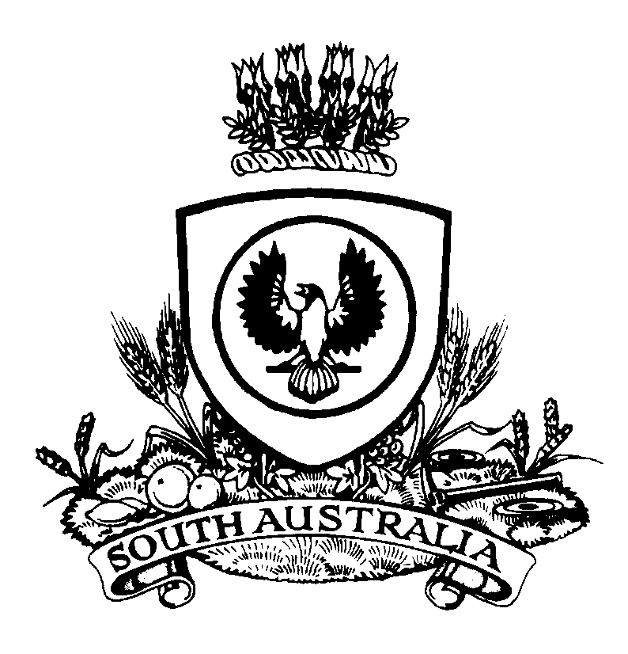 |  |  | ORDER FOR RESTORATION OF MONETARY AMOUNT  Magistrates Court of South Australia  www.courts.sa.gov.au  Fines Enforcement and Debt Recovery Act 2017  Section 46(11) |  |  |  |  |  |  |  |  |  |  |  | Court Use  Date Filed:
Registry |  |  |  |  |  |  |  |  |  |  | File No
Address
 | Street |  |  |  |  |  |  | Telephone |  |  |  |  |  | Facsimile |  |  | DX
 | City/Town/Suburb |  |  | State |  | Postcode |  |  | Email Address
Debtor
Full Name |  |  |  |  |  |  |  |  |  |  |  |  |  |  |  | DOB
Address
 |  | Street |  |  |  |  |  |  |  | Telephone |  |  |  |  |  | Facsimile
 |  | City/Town/Suburb |  |  | State |  | Postcode |  |  |  |  | Email Address
Details of the Order
I revoke the Community Service Order or the Approved Treatment Program Order on the basis that the debtor/alleged offender has the means to pay the monetary amount without the debtor/alleged offender, or their dependants suffering hardship. I order restoration of the monetary amount in the amount of .
Date of Order:
Date MAGISTRATE / REGISTRAR / JUSTICE OF THE PEACE

